**Data Mining Project Business Report**

**On**

**Bank Marketing**

**Insurance**

**By,**

**Keshav Raj Singh Rathore**

**PGPDBA**

**2022-2023**

**Project Objective**

**Problem 1: Clustering**

A leading bank wants to develop a customer segmentation to give promotional others to is customers. They collected a sample that summarizes the activities of users during the past few months. You are given the ask to identify the segments based on credit card usage

**1.1** Read the data, do the necessary initial steps, and exploratory data analysis (Univariate, Bi-variate, and multivariate analysis).

**1.2** Do you think scaling is necessary for clustering in this case? Justify

**1.3** Apply hierarchical clustering to scaled data. Identify the number of optimum clusters using Dendrogram and briefly describe them

**1.4** Apply K-Means clustering on scaled data and determine optimum clusters. Apply elbow curve and silhouette score. Explain the results properly. Interpret and write inferences on the finalized clusters.

**1.5** Describe cluster profiles for the clusters defined. Recommend different promotional strategies for different clusters.

**Problem 2: CART-RF-ANN**

An Insurance firm providing tour insurance is facing higher claim frequency. The management decides to collect data from the past few years. You are assigned the task to make a model which predicts the claim status and provide recommendations to management. Use CART, RF & ANN and compare the models' performances in train and test sets.

**2.1** Read the data, do the necessary initial steps, and exploratory data analysis (Univariate, Bi-variate, and multivariate analysis).

**2.2** Data Split: Split the data into test and train, build classification model CART, Random Forest, Artificial Neural Network

**2.3** Performance Metrics: Comment and Check the performance of Predictions on Train and Test sets using Accuracy, Confusion Matrix, Plot ROC curve and get ROC_AUC score, classification reports for each model. 

**2.4** Final Model: Compare all the models and write an inference which model is best/optimized.

**2.5** Inference: Based on the whole Analysis, what are the business insights and recommendations

Table of contents

|  |  |  |  |
| --- | --- | --- | --- |
| Chapter No. | | Title | Page No. |
| 1 |  | Project Objective |  |
|  | 1.1 | Problem 1: Clustering |  |
|  | 1.2 | Assumption |  |
|  | 1.3 | Importing Packages |  |
|  | 1.4 | Solution 1.1 Read the data, do the necessary initial steps, and exploratory data analysis (Univariate, Bi-variate, and multivariate analysis). |  |
|  | 1.5 | Solution 1.2 Do you think scaling is necessary for clustering in this case? Justify |  |
|  | 1.6 | Solution 1.3 Apply hierarchical clustering to scaled data. Identify the number of optimum clusters using Dendrogram and briefly describe them |  |
|  | 1.7 | Solution 1.4 Apply K-Means clustering on scaled data and determine optimum clusters. Apply elbow curve and silhouette score. Explain the results properly. Interpret and write inferences on the finalized clusters |  |
|  | 1.8 | Solution 1.5 Describe cluster profiles for the clusters defined. Recommend different promotional strategies for different clusters |  |
| 2 |  | **Problem 2: CART-RF-ANN** |  |
|  | 2.1 | Assumption |  |
|  | 2.2 | Solution 2.1 Read the data, do the necessary initial steps, and exploratory data analysis (Univariate, Bi-variate, and multivariate analysis). |  |
|  | 2.3 | Solution 2.2 Data Split: Split the data into test and train, build classification model CART, Random Forest, Artificial Neural Network |  |
|  | 2.4 | Solution 2.3 Performance Metrics: Comment and Check the performance of Predictions on Train and Test sets using Accuracy, Confusion Matrix, Plot ROC curve and get ROC_AUC score, classification reports for each model. |  |
|  | 2.5 | Solution 2.4 Final Model: Compare all the models and write an inference which model is best/optimized |  |
|  | 2.6 | Solution 2.5 Inference: Based on the whole Analysis, what are the business insights and recommendations |  |
|  |  | Reference |  |

Problem 1: Clustering

**Assumption**

## Data Dictionary for Market Segmentation:

* spending: Amount spent by the customer per month (in 1000s)
* advance payments: Amount paid by the customer in advance by cash (in 100s)
* probability_of_full_payment: Probability of payment done in full by the customer to the

bank

* current_balance: Balance amount left in the account to make purchases (in 1000s)
* credit_limit: Limit of the amount in credit card (10000s)
* min_payment_amt: minimum paid by the customer while making payments for

purchases made monthly (in 100s)

* max_spent_in_single_shopping: Maximum amount spent in one purchase (in 1000s)

**Importing Packages**

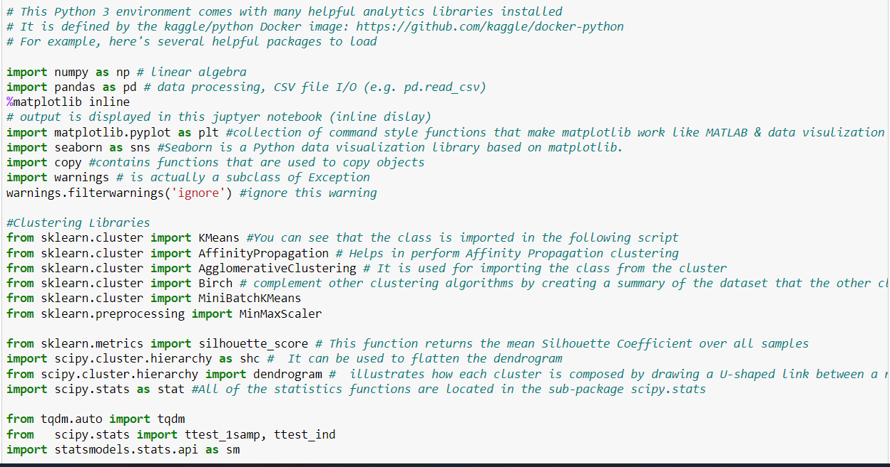

## Q1.1 Read the data, do the necessary initial steps, and exploratory data analysis (Univariate, Bi-variate, and multivariate analysis).

Head: - Head is used to return top row in data set

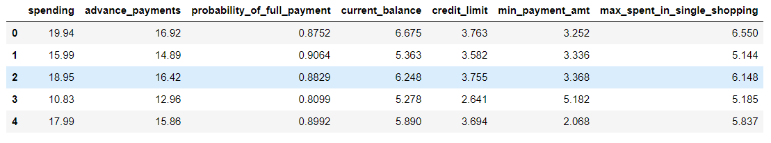

Tail: - Tail is used to return last row in data set

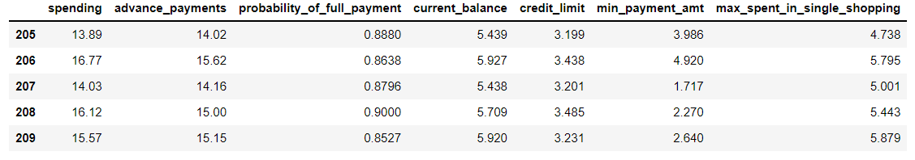

Observation

Data looks good based on initial records seen in top 5 and bottom 5.

## Summary of dataset: -

### Attribute Information: -

**Info():-**

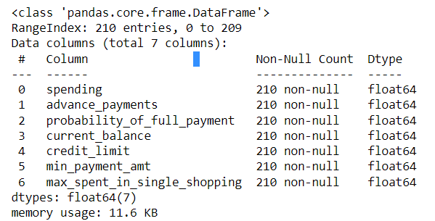

**Checking the null value:-**

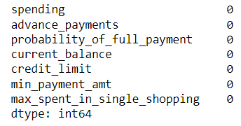

**Observation: -**

7 variables and 210 records.

No missing record based on initial analysis.

All the variables numeric type.

## EDA

We are going to start exploring our data with the Univariate analysis (each feature individually), before carrying the Bivariate analysis and compare pairs of features to find correlation between them.

## Univariate analysis: -

**Descriptive Statistics of our Data:**

## 

**Observation**: -

* Based on summary descriptive, the data looks good.
* We see for most of the variable, mean/medium are nearly equal
* Include a 90% to see variations and it looks distributed evenly
* Std Deviation is high for spending variable

## Detecting the outliers using Boxplot and Distribution Hist plot

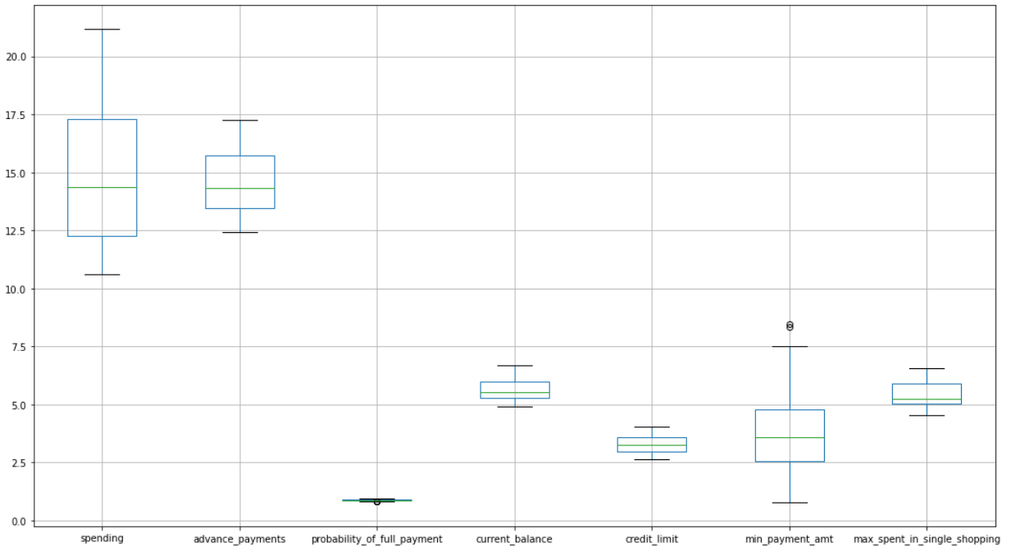

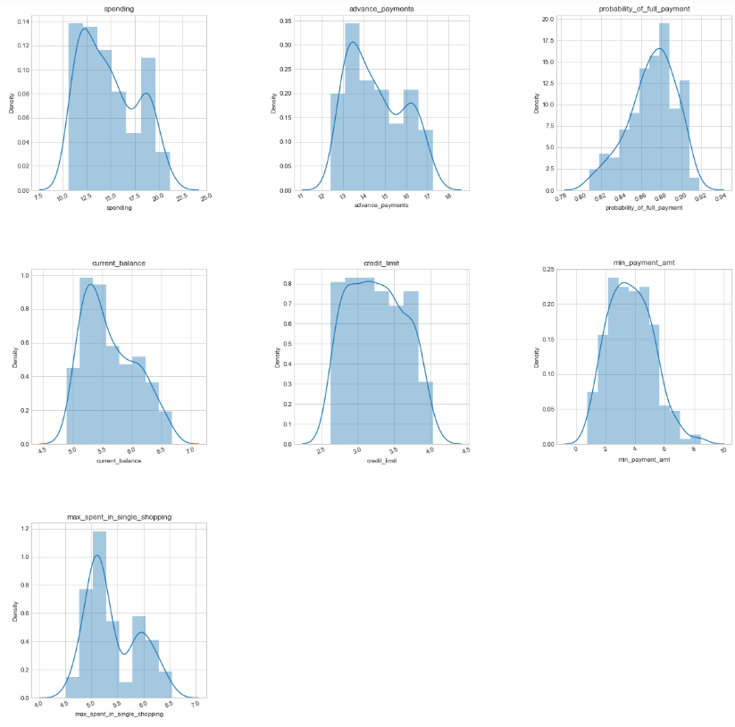

## To ignore the outliers from the calculation of the mean and standard deviation, we use to calculated values to z-scale the variable and perform Interquartile Range Formula.

## DATA after Scaling and removing of Outliers

## Boxplot

**Distribution Histogram Plot**

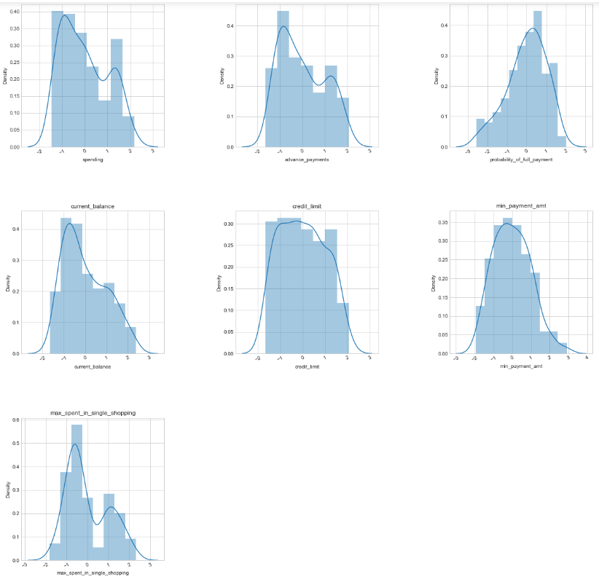

## Observation_: -

## As we have removed the outlier and check the data again, we can see that we have some changes in 2 columns within data set Probability_of_full_payment and min_payment_amt.

## Kindly Note: - For the Below calculation we are using original dataset and not the Scaled one

## 1). Spending: Amount spent by the customer per month (in 1000s)

. Range of values: 10.59

. Minimum spending: 10.59

Maximum spending: 21.18

Mean value: 14.847523809523818

Median value: 14.355

Standard deviation: 2.909699430687361

Null values: False

. spending - 1st Quartile (Q1) is: 12.27

spending - 3rd Quartile (Q3) is: 17.305

**2). Advance_payments: Amount paid by the customer in advance by cash (in 100s)**

. Range of values: 4.84

. Minimum advance_payments 12.41

Maximum advance_payments: 17.25

Mean value: 14.559285714285727

Median value: 14.32

Standard deviation: 1.305958726564022

Null values: False

. advance_payments - 1st Quartile (Q1) is: 13.45

advance_payments - 3rd Quartile (Q3) is: 15.715

## 3). Probability_of_full_payment: Probability of payment done in full by the customer to the bank

. Range of values: 0.11019999999999996

. Minimum probability_of_full_payment 0.8081

Maximum probability_of_full_payment: 0.9183

Mean value: 0.8709985714285714

Median value: 0.8734500000000001

Standard deviation: 0.0236294165838465

Null values: False

. probability_of_full_payment - 1st Quartile (Q1) is: 0.8569

probability_of_full_payment - 3rd Quartile (Q3) is: 0.887775

## 4). current_balance: Balance amount left in the account to make purchases (in 1000s)

. Range of values: 1.7759999999999998

. Minimum current_balance: 4.899

Maximum current_balance: 6.675

Mean value: 5.628533333333335

Median value: 5.5235

Standard deviation: 0.44306347772644944

Null values: False

. current_balance - 1st Quartile (Q1) is: 5.26225

current_balance – 3rd Quartile (Q3) is: 5.97975

## 5). credit_limit: Limit of the amount in credit card (10000s)

. Range of values: 1.4030000000000005

. Minimum current_balance: 2.63

Maximum current_balance: 4.033

Mean value: 3.258604761904763

Median value: 3.237

Standard deviation: 0.37771444490658734

Null values: False

. credit_limit - 1st Quartile (Q1) is: 2.944

credit_limit – 3rd Quartile (Q3) is: 3.56175

## 6) min_payment_amt : minimum paid by the customer while making payments for purchases made monthly (in 100s)

. Range of values: 7.690899999999999

. Minimum current_balance: 0.7651

Maximum current_balance: 8.456

Mean value: 3.7002009523809503

Median value: 3.599

Standard deviation: 1.5035571308217792

Null values: False

. min_payment_amt - 1st Quartile (Q1) is: 2.5615

min_payment_amt - 3st Quartile (Q3) is: 4.76875

## 7). max_spent_in_single_shopping: Maximum amount spent in one purchase (in 1000s)

. Range of values: 2.0309999999999997

. Minimum current_balance: 4.519

Maximum current_balance: 6.55

Mean value: 5.408071428571429

Median value: 5.223000000000001

Standard deviation: 0.49148049910240543

Null values: False

. max_spent_in_single_shopping - 1st Quartile (Q1) is: 5.045

max_spent_in_single_shopping – 3rd Quartile (Q3) is: 5.877

## Lets Try the Multivariate analysis

Creating the pair plot to pairwise relationships in a Scaled dataset

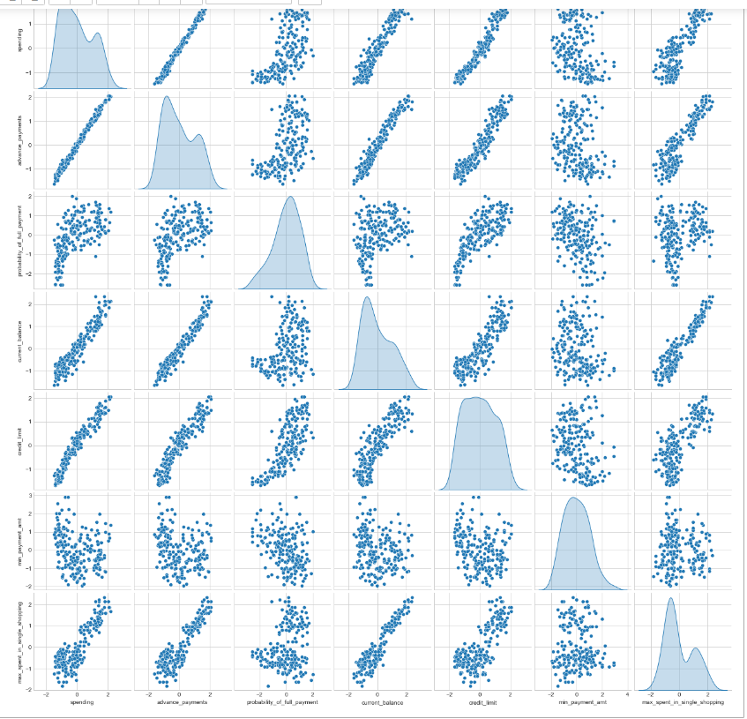

Creating correlation matrix

## 

## Observation:-

- Strong positive correlation between

- spending & advance_payments,

- advance_payments & current_balance,

- credit_limit & spending

- spending & current_balance

- credit_limit & advance_payments

- max_spent_in_single_shopping current_b

## Note:-

-As we have performed the z-score Scaling method earlier no need to repeat it again

-Most of the outlier has been treated and now we are good to go.

**-We have checked the correlation between the variables and performed the necessary steps**

## Q1.2 Do you think scaling is necessary for clustering in this case? Justify?

## Ans:-

Scaling needs to be done as the values of the variables are different.

spending, advance_payments are in different values, and this may get more weightage.

Also have shown below the plot of the data prior and after scaling.

Scaling will have all the values in the relative same range.

I have used z score to standardise the data to relative same scale -3 to +3.

**# Prior to Scaling**

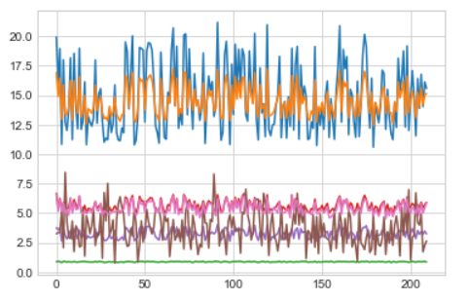

#After Scaling

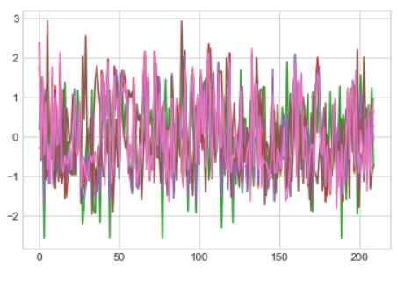

## Q 1.3 Apply hierarchical clustering to scaled data. Identify the number of optimum clusters using Dendrogram and briefly describe them?

## Ans:-

## Creating the Dendrogram

## Importing dendrogram and linkage module

## Choosing Ward linkage method

## Importing fcluster module to create clusters

## Method 1(using maximum cluster)

## Method 2(using distance cluster)

## Attaching Distance_cluster to dataset

## Wardlink Cluster Frequency

## Max Cluster

1 70

2 67

3 73

Name: cluster_1, dtype: int64

## Distance Cluster

1 70

2 140

Name: cluster_2, dtype: int64

## Wardlink Cluster Profiles

## Cluster 1:-

**Cluster 2:-**

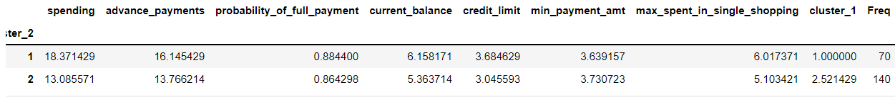

## Choosing Average linkage method

## Creating the Dendrogram

## Importing dendrogram and linkage module

## 

## Importing fcluster module to create clusters

Method 1(Using Distance Cluster)

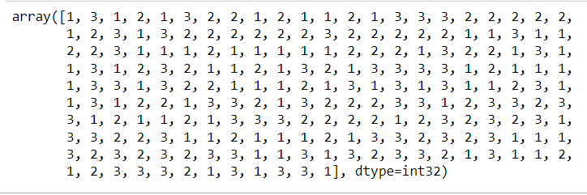

Method 2(Using Distance Cluster)

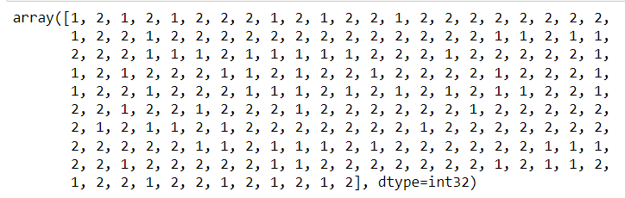

## Attaching Distance_cluster to dataset

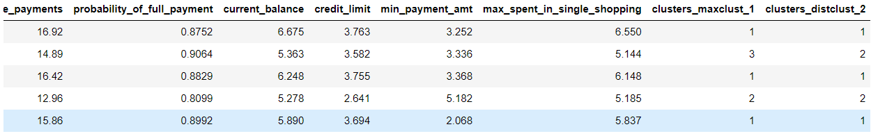

## Average Link Cluster Frequency

## Max Cluster

1 75

2 70

3 65

Name: clusters_maxclust_1, dtype: int64

## Distance Cluster

1 70

2 140

Name: clusters_distclust_2, dtype: int64

## Wardlink Cluster Profiles

## Cluster 1:-

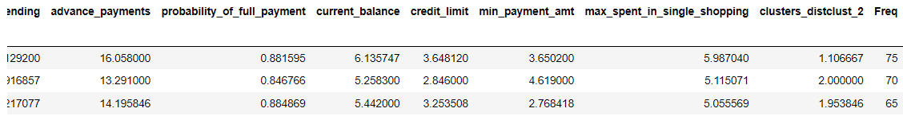

**Cluster 2:-**

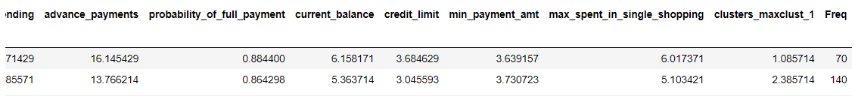

**Observation**

Both the method are almost similar means, minor variation, which we know it occurs.

We for cluster grouping based on the dendrogram, 3 or 4 looks good. Did the further analysis, and based on the dataset had gone for 3 group cluster solution based on the hierarchical clustering

Also in real time, there could have been more variables value captured - tenure, BALANCE_FREQUENCY, balance, purchase, instalment of purchase, others.

And three group cluster solution gives a pattern based on high/medium/low spending with max_spent_in_single_shopping (high value item) and probability_of_full_payment (payment made).

## Q1.4 Apply K-Means clustering on scaled data and determine optimum clusters. Apply elbow curve and silhouette score. Explain the results properly. Interpret and write inferences on the finalized clusters.

## Ans: -

## No need to use scaling as we have done it previously

## a). Inertia value for cluster 1

1466.2981569540962

## b). Inertia value for cluster 2

655.6870659927683

## c). Inertia value for cluster 3

427.97721673953674

## d). Inertia value for cluster 4

369.24497239677646

## e). Inertia value for cluster 5

324.92124005418947

## f). Inertia value for cluster 6

287.2470652229741

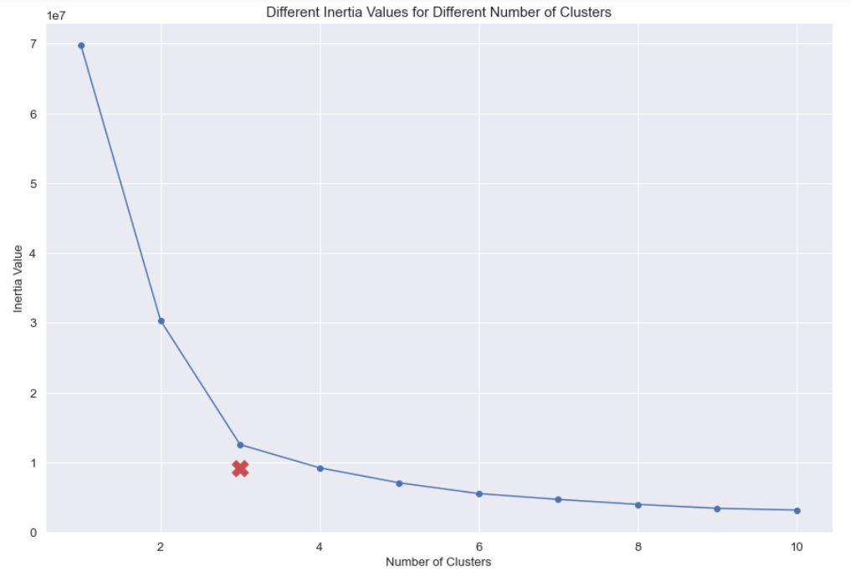

The red x-marker marks the elbow point. The elbow point gives the optimal number of clusters, which is three here. This makes totally sense, because the data set is created such that there are three different clusters. When adding more clusters, the Inertia value decreases, but also the information contained in a cluster decreases further.

**With in Clusters Sum Of Squares(WSS)**

[1466.2981569540962,

655.6870659927683,

427.97721673953674,

368.78556067979645,

325.300889806876,

286.97320612800434,

261.0611695310443,

241.2050222376149,

221.73044378344304,

207.5397773584225]

## Ploting the information fo wss

## Creating the variable column for K_Means cluster value in original dataset

## Silhouette Score Function

[0.4664503844092787,

0.4011595738574594,

0.3353135222714839,

0.28525049397538355,

0.2711971584511046,

0.2761977187595437,

0.2621053551578649,

0.26593316038116327,

0.26621800629709286]

## Plotting the Silhouette Scores

## 

## Insights

From SC Score, the number of optimal clusters could be 3 or 4

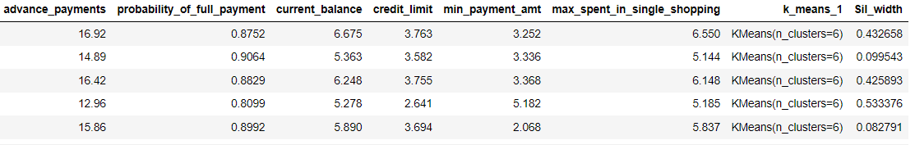

## Silhouette Samples

-0.051158059328679784

## 3 Cluster Solution

# Fitting the K means

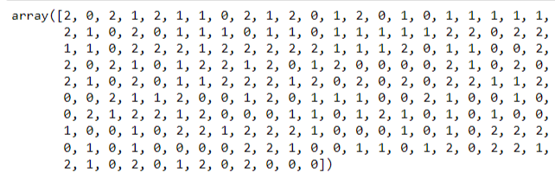

#Proportion of labels Classified

1 72

0 71

2 67

dtype: int64

## K-Means Clustering & Cluster Information

## Cluster Percentage

## #Transposing the cluster

## 

## Note:-

I am going with 3 clusters via k means, but am showing the analysis of 4 and 5 k means cluster, I see we based on current dataset given, 3 cluster solution makes sense based on the spending pattern (High, Medium, Low)

## 4-Cluster Solution

## #Fitting the K means

## #Proportion of labels Classified

3 65

1 64

0 51

2 30

dtype: int64

**K-Means Clustering & Cluster Information**

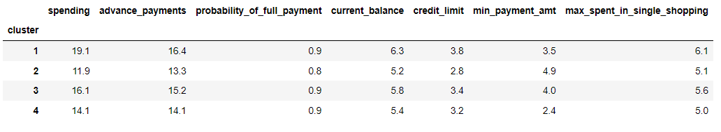

**Cluster Percentage**

## #Transposing the Cluster

## 5 cluster

## #Fitting the K means

## #Proportion of labels Classified

## K-Means Clustering & Cluster Information

## Cluster Percentage

## 

## #Transposing the Cluster

## Q 1.5 Describe cluster profiles for the clusters defined. Recommend different promotional strategies for different clusters?

## Ans:

## 3 group cluster via Kmeans

## 

## 3 group cluster via hierarchical clustering

## 

# **Cluster Group Profiles**

## Promotional strategies for each cluster

## Group 1: High Spending Group

* Giving any reward points might increase their purchases.
* maximum max_spent_in_single_shopping is high for this group, so can be offered discount/offer on next transactions upon full payment
* Increase their credit limit and
* Increase spending habits
* Give loan against the credit card, as they are customers with good repayment record.
* Tie up with luxury brands, which will drive more one_time_maximun spending

## Group 2: Medium Spending Group

* They are potential target customers who are paying bills and doing purchases and maintaining comparatively good credit score. So, we can increase credit limit or can lower down interest rate.
* Promote premium cards/loyalty cars to increase transactions.
* Increase spending habits by trying with premium ecommerce sites, travel portal, travel airlines/hotel, as this will encourage them to spend more

## Group 3: Low Spending Group

* customers should be given remainders for payments. Offers can be provided on early payments to improve their payment rate.
* Increase their spending habits by tieing up with grocery stores, utilities (electricity, phone, gas, others)

## ****Problem 2: CART-RF-ANN****

**Assumption**

**Attribute** **Information:**

## 1. Target: Claim Status (Claimed) 2. Code of tour firm (Agency_Code) 3. Type of tour insurance firms (Type) 4. Distribution channel of tour insurance agencies (Channel) 5. Name of the tour insurance products (Product) 6. Duration of the tour (Duration in days) 7. Destination of the tour (Destination) 8. Amount worth of sales per customer in procuring tour insurance policies in rupees (in 100’s) 9. The commission received for tour insurance firm (Commission is in percentage of sales) 10.Age of insured (Age)

## **2.1** Read the data, do the necessary initial steps, and exploratory data analysis (Univariate, Bi-variate, and multivariate analysis).

## Inspect the data:-

Head: - Head is used to return top row in data set

Tail: - Tail is used to return last row in data set

Observation

Data looks good based on initial records seen in top 5 and bottom 5.

## Summary of dataset: -

## EDA

### Attribute Information: -

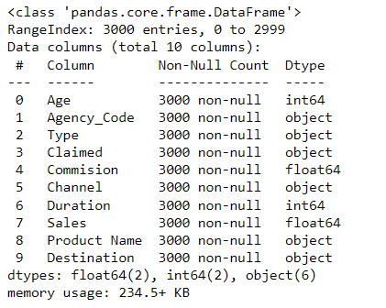

**Null value**

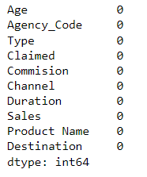

## Shape of Data

(3000, 10)

Observation:

7 variables and 210 records.

No missing record based on initial analysis.

Aggency_code, Type, Claimed, Channel, Product Name and Destination variable has numeric data, but data type is object. It appears some special character is present in this variable. Also, there are no missing values in variables.

Converting Object data type into Categorical

## Data Head

### Attribute Information: -

## Dataset Mean

## 

## Univariate analysis: -

**Descriptive Statistics of our Data:**

**Observation**: -

* Based on summary descriptive, the data looks good.
* We see for most of the variable, mean/medium are high different
* Include a 90% to see variations and it looks distributed evenly
* Std Deviation is high for Duration Variable
* Max value is highest for Duration Variable

## Duplicates

Number of duplicate rows = 139(for accurate Calculation we drop all)

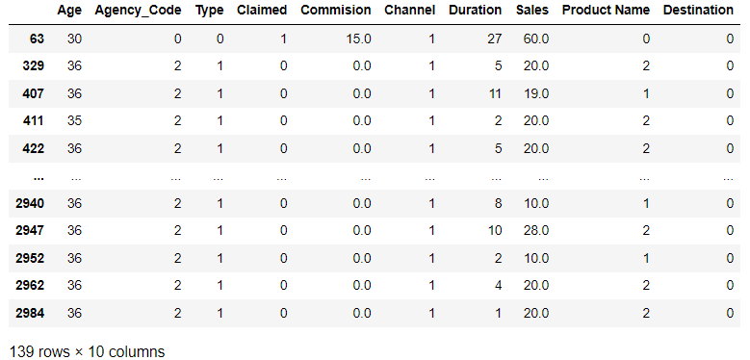

## Checking for the Outlier

**Distribution Histogram Plot**

## Note: - Very small number of outliers are present, which is also not significant as it will not affect much on ANN Predictions

## Lets Try the Multivariate analysis

## Checking pairwise distribution of the continuous variables

## 

## Checking for Correlations using Heatmap

## Observation: -

## There is hardly any correlation between the variables except sales and commission.

## Q **2.2** Data Split: Split the data into test and train, build classification model CART, Random Forest, Artificial Neural Network

## ANS:-

## Decision Tree

## -Capture the target column into separate vectors for training set and test set.

## -Splitting data into training and test set.

## Let’s Check Train Data Set

0 1359

1 643

Name: Claimed, dtype: int64

## Let’s Check Train Data Set for normalized set

0 0.678821

1 0.321179

Name: Claimed, dtype: float64

## Let’s Check Test Data Set

0 588

1 271

Name: Claimed, dtype: int64

## Let’s Check Test Data Set for normalized set

0 0.684517

1 0.315483

Name: Claimed, dtype: float64

## Observations: -

Train label and Test label are almost equally distributed between the train and test sets w.r.t target classes.

## Declaring Decision Tree Classifier as dt_model

## We are using Gini for the Decision Tree Classifier because Gini impurity is an important measure used to construct the decision trees. Gini impurity is a function that determines how well a decision tree was split

## Tree Sub Module (Exo Graphical function)

## We are creating sub module by importing the tree sub module in dot_data.

## Regularizing the decision tree

DecisionTreeClassifier (max_depth=7, min_samples_leaf=10, min_samples_split=30)

## Feature_Importances for Regularizing

## 

## Creating Data Frame for Feature_Importances for dt model

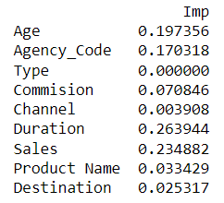

## 

## **2.3** Performance Metrics: Comment and Check the performance of Predictions on Train and Test sets using Accuracy, Confusion Matrix, Plot ROC curve and get ROC_AUC score, classification reports for each model.

## 

## ANS:

## Probability in Prediction Model

**Train Labels**



## Train Predict Model Probability

## 

## Train Predict Model Probability data frame head

## Test Labels

## 

## Test Predict Model Probability

## 

## Test Predict Model Probability data frame head

## Measuring AUC-ROC Curve

Train Labels AUC And ROC Curve

Test Labels AUC And ROC Curve

## Observation:

## From the above ROC curve, we can clearly see that AUC value for Test label data is between 0.7 to 0.8 which is Acceptable discrimination and for Train label data is between 0.8 to 0.9 which is Excellent discrimination.

## Confusion Matrix for train data

1. **TN / True Negative**: the case was negative and predicted negative (1213)
2. **TP / True Positive**: the case was positive and predicted positive (376)
3. **FN / False Negative**: the case was positive but predicted negative (267)
4. **FP / False Positive**: the case was negative but predicted positive (146)

## Getting classification report for train labels

## Confusion Matrix for test data

1. **TN / True Negative**: the case was negative and predicted negative (508)
2. **TP / True Positive**: the case was positive and predicted positive (155)
3. **FN / False Negative**: the case was positive but predicted negative (116)
4. **FP / False Positive**: the case was negative but predicted positive (80)

## Getting classification report for test labels

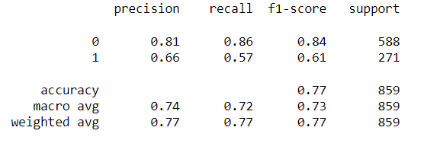

## Random Forest

## Build random forest classifier

## # Getting out of bag Score (OOB Score)

0.7592407592407593

# Grid search cross validation (IT Passes Multiple value for max depth and estimator)

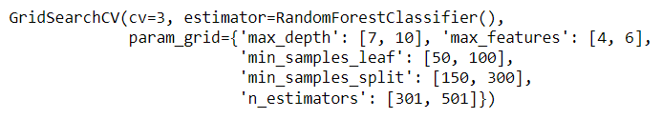

# Grid to get best parameter option



## Creating Confusion Matrix in Random Forest

## Confusion Matrix for Train Labels in Random Forest

## 

1. **TN / True Negative**: the case was negative and predicted negative (1209)
2. **TP / True Positive**: the case was positive and predicted positive (330)
3. **FN / False Negative**: the case was positive but predicted negative (313)
4. **FP / False Positive**: the case was negative but predicted positive (150)

## Getting classification report for Random Forest Train labels

## 

## Confusion Matrix for Train Labels in Random Forest

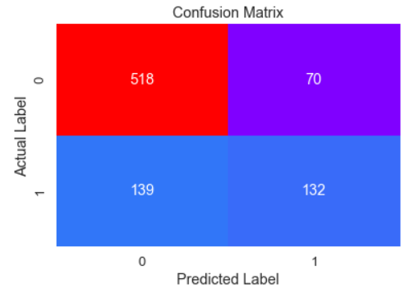

1. **TN / True Negative**: the case was negative and predicted negative (518)
2. **TP / True Positive**: the case was positive and predicted positive (132)
3. **FN / False Negative**: the case was positive but predicted negative (139)
4. **FP / False Positive**: the case was negative but predicted positive (70)

Getting classification report for Random Forest Test labels

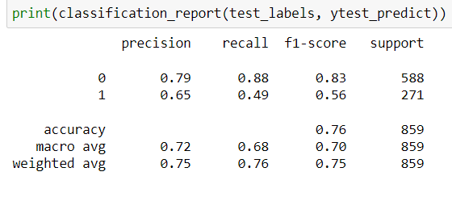

## Roc Curve And AUC Score

**Roc and AUC curve for Train Labels**

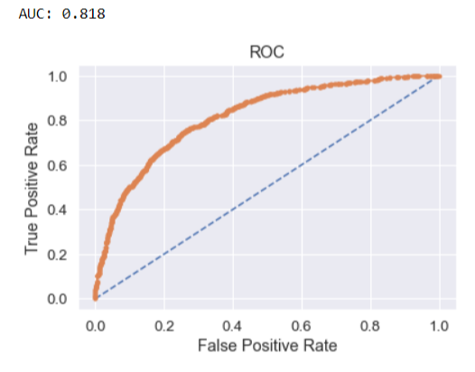

**Roc and AUC curve for Test Labels**

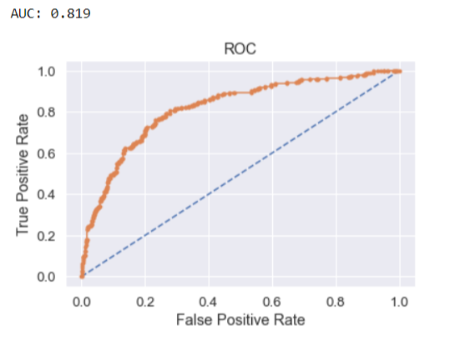

## Observation:

## From the above ROC curve, we can clearly see that AUC value for Test label data is between 0.8 to 0.9 which is Excellent discrimination and for Train label data is between 0.8 to 0.9 which is Excellent discrimination.

## AUC for both Train label and Test Label in Random Forest showed nearly Similar score.

## Artificial Neural Network

Scaling Method

## Normalization is one of the main part of ANN learning process, its necessary to be performed to normalize the input between (0,1) or(-1,1).

## For the Scaling purpose we are using the StandardScalar and putting it as (SC) in our data set.

## Next, we are using Multi-layer Perceptron classifier {MLP}which in the name itself connects to a Neural Network

## GridSearchCV

## To loop through predefined hyperparameters and fit your estimator(model) on training data set we use GridSearchCv.

## Predict Score

## Train label Prediction score

## 

## Test label Prediction Score

## 

## Roc Curve and AUC Score

## ROC Curve AND AUC Score for Train Label in Artificial Neural Network

## 

## ROC Curve AND AUC Score for Test Label in Artificial Neural Network

## 

## Confusion Matrix

## Confusion Matrix for Train Labels in Artificial Neural Network

1. **TN / True Negative**: the case was negative and predicted negative (1235)
2. **TP / True Positive**: the case was positive and predicted positive (310)
3. **FN / False Negative**: the case was positive but predicted negative (333)
4. **FP / False Positive**: the case was negative but predicted positive (124)

Getting classification report for artificial Neural Network Train labels

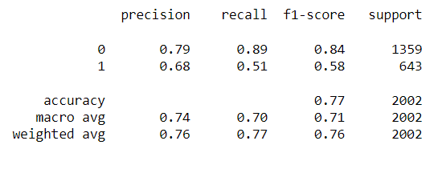

## Confusion Matrix for Test Labels in Artificial Neural Network

## **TN / True Negative**: the case was negative and predicted negative (529)

## **TP / True Positive**: the case was positive and predicted positive (120)

## **FN / False Negative**: the case was positive but predicted negative (151)

## **FP / False Positive**: the case was negative but predicted positive (59)

## Getting classification report for artificial Neural Network Train labels

## 

# **2.4 Final Model: Compare all the model and write an inference which model is best/optimized.**

Ans:

# Comparison of the performance metrics from the 3 models

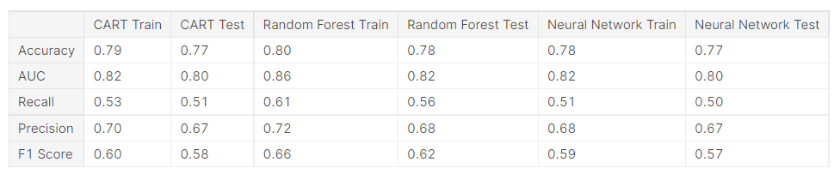

# ROC Curve for the 3 models on the Training data

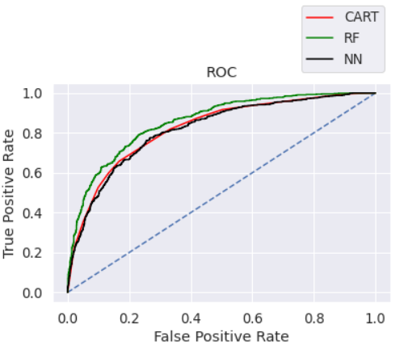

# **ROC Curve for the 3 models on the Test data**

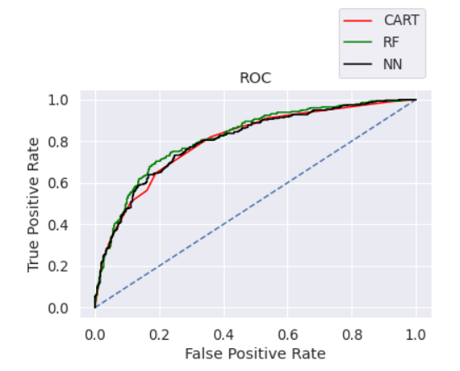

# CONCLUSION:

# I am selecting the RF model, as it has better accuracy, precision, recall, f1 score better than other two CART & NN.

# 2.5 Inference: Basis on these predictions, what are the business insights and recommendations

Ans:

I strongly recommended we collect more real time unstructured data and past data if possible.

This is understood by looking at the insurance data by drawing relations between different variables such as day of the incident, time, age group, and associating it with other external information such as location, behaviour patterns, weather information, airline/vehicle types, etc.

• Streamlining online experiences benefitted customers, leading to an increase in conversions, which subsequently raised profits. • As per the data 90% of insurance is done by online channel. • Other interesting fact, is almost all the offline business has a claimed associated, need to find why? • Need to train the JZI agency resources to pick up sales as they are in bottom, need to run promotional marketing campaign or evaluate if we need to tie up with alternate agency • Also based on the model we are getting 80%accuracy, so we need customer books airline tickets or plans, cross sell the insurance based on the claim data pattern. • Other interesting fact is more sales happen via Agency than Airlines and the trend shows the claim are processed more at Airline. So, we may need to deep dive into the process to understand the workflow and why?

Key performance indicators (KPI) The KPI’s of insurance claims are: • Reduce claims cycle time • Increase customer satisfaction • Combat fraud • Optimize claims recovery • Reduce claim handling costs Insights gained from data and AI-powered analytics could expand the boundaries of insurability, extend existing products, and give rise to new risk transfer solutions in areas like a non-damage business interruption and reputational damage.